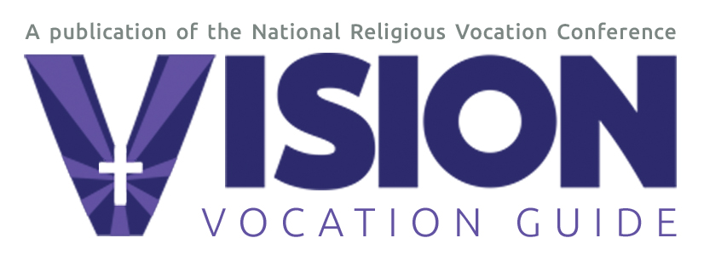

VocationNetwork.org
Contact: Patrice Tuohy phone: 312.356.9900 or 773.516.0699
e-mail: patrice@vocationnetwork.org web: VocationNetwork.org

Vision Vocation Guide’s special issue for the Year of Consecrated Life includes survey of Catholics and newly composed song
94 percent of Catholics surveyed have positive view of religious sisters, brothers, priests
96 percent of responding men and women religious optimistic about future of consecrated life

Chicago, Sept. 2, 2014―In honor of the Catholic Church’s Year of Consecrated Life (Nov. 2014 through Feb. 2016), the recently published 2015 VISION Vocation Guide features a survey of Catholics’ views on consecrated life, a Consecrated Life Timeline, and a specially commissioned song, “Wake the world with dawning joy” by acclaimed Catholic composer Steven Warner.

Sisters, brothers, priests: Make yourselves more visible
With 2,030 respondents, the VISION 2015 survey captures the mood of Catholics of all ages and walks of life, including those discerning a religious vocation, members of religious communities, parish ministers, and Catholic parishioners. With 94 percent of all respondents reporting a positive view of consecrated life, they found the most attractive aspects of religious life to be “shared prayer and spirituality” and “service to others.” Among men and women in consecrated life who completed surveys, 96 percent reported they were optimistic about the future of consecrated life.

Among the things that respondents would change about consecrated life, the overwhelming majority thought that men and women in religious life should make themselves more visible to the public. They also noted that the church should do more to promote religious life. As one young woman in her 20s said, “The only way vocations are mentioned is if a parishioner brings it up. There seems to be a lack overall in knowledge on how to help men and women who are curious about their vocation.”

“What is most encouraging,” says Br. Paul Bednarczyk, C.S.C., Executive Director of the National Religious Vocation Conference, “is that more than 70 percent of survey participants have invited someone to consider religious life. Ideally the promotion of vocations is the responsibility of the entire church, not only of the clergy or religious themselves.”

The complete survey results can be found in print or in the digital edition online at: http://www.digitalvocationguide.org/vision/2015#pg70.

Sing a new song
The 2015 VISION Vocation Guide also contains the sheet music and lyrics for “Wake the World with Dawning Joy,” a song by Steven Warner, director of the University of Notre Dame Folk Choir, specially commissioned by the National Religious Vocation Conference and VISION Vocation Guide in honor of the Year of Consecrated Life. The full score is available for download on the VISION website, VocationNetwork.org, and an audio recording will be available later this month. Parishes are encouraged to sing the song at liturgies throughout the Year of Consecrated Life and beyond.

Two posters for promoting vocations
Other Year of Consecrated items included in the 2015 VISION Vocation Guide are a special 16” x 21” pullout poster of “Consecrated Life through the Ages,” and a multilingual parish poster calling on individuals to “Wake up the world!” just as Pope Francis has asked of men and women in consecrated life.

“Our hope is that parishes, catechists, and campus ministers will find the special features in the 2015 VISION Vocation Guide and on the VocationNetwork.org website useful as they plan activities in the Year of Consecrated Life to promote vocations and invite others to consider life as a religious sister, brother, or priest,” says Patrice Tuohy, executive editor of VISION Vocation Guide.

The 2015 issue also contains its regular features on prayer, discernment, and religious life; profiles on religious sisters, brothers, and priests; and a men’s and women’s community directory. VISION’s award-winning Vocation Network website features an extensive calendar of vocation-related events and its popular Vocation Match service.

# # #
Vision Vocation Guide, in print and online at VocationNetwork.org, is published by TrueQuest Communications on behalf of the National Religious Vocation Conference, NRVC.net. With its unique multimedia, multilingual, and interactive features, including VocationMatch.com, it is the most comprehensive resource available for those considering a religious vocation in the Catholic Church or interested in learning more about religious orders, consecrated life, or vocation-related opportunities. VISION is a member publication of the Catholic Press Association and winner of numerous awards for editorial excellence in print and online. VocationNetwork.org was named a top-ten vocation website by the United States Conference of Catholic Bishops.

